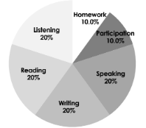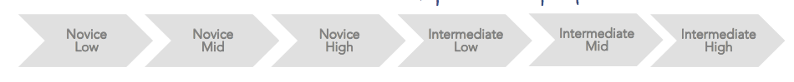

* Class will be conducted in Spanish at least 80% of the time. In order to learn to communicate in Spanish, you must listen, read, write and speak in Spanish as much as possible.
* We will do our own work. This means we will not use online translators. Use [wordreference.com](http://wordreference.com).
* The goal is to move forward in our proficiency, so if you are absent, it is your responsibility to check the absent folder, our class site, ask a friend, and then Sra. what you missed, and make it up as soon as possible.
* We will have a supportive and positive learning environment where everyone helps each other to learn and grow.
* We will take responsibility for our own educations and participate actively in class and out of class.
* If you are struggling REACH OUT! I would love to connect you to helpful resources ☺

**What will we do in Spanish class?**

The basis of Spanish 2 is cultural study units,

which include telling stories, listening to music,

and reading the novels Esperanza, and El nuevo Houdini

Let’s have an amazing year learning to communicate in Spanish. If you ever need anything, just ask! ~ Señorita B.

**How to get there?**

**ESPAñol 2 learning targets**

* INTERPRETIVE LISTENING - I can understand familiar words, phrases & sentences that I hear, including some details in Spanish.
* INTERPRETIVE READING- I can understand familiar words, phrases & sentences that I read, including some details in Spanish.
* INTERPERSONAL SPEAKING - I can ask & answer simple questions using phrases, simple sentences, and memorized language on familiar topics.
* PRESENTATIONAL WRITING - I can present basic information in writing about familiar topics related to everyday life using phrases, simple sentences, and language I have practiced in Spanish.

# **STANDARD BASED GRADING**

Advanced: EXCEEDS Expectations (95%+)

Proficient: MEETS Expectations (85%)

Developing: APPROACHING Expectations (75%)

Emerging: ATTEMPTING Expectations (65%)

Beginning: BELOW Expectations. (55%)

No attempt (0%)

* Final Grade: 80% semester, 20% exam
* Late work: Homework: 50% (highest possible) and projects 80% if turned in next day. After that, the highest possible grade on a project is a 50%/

**GOAL**

# **What do I need to be successful for class?**

* A positive attitude - EVERYONE can learn a language
* A binder (preferably between 1-2 inches)
* A charged chromebook
* A notebook/lined paper and a writing utensil

BRING IN BY: ____________________

español 2- Señorita Bailey

Room 107 Email: bbailey@westmichiganaviation.org

LEARNING A language IS A MESSY process!