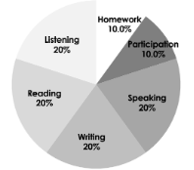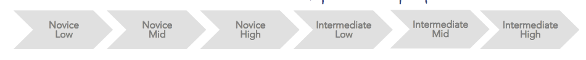

**ESPAñol 4 learning targets**

* INTERPRETIVE LISTENING - I can understand familiar words, phrases & sentences that I hear, including many details in Spanish. And interpret the unfamiliar for understanding
* INTERPRETIVE READING- I can understand familiar and determine meaning for unfamiliar words, phrases & sentences that I read.
* INTERPERSONAL SPEAKING - I can ask & answer questions using phrases, complex sentences, and in-the-moment language on familiar topics and unfamiliar topics.
* PRESENTATIONAL WRITING - I can present information in writing about a variety of topics using complex and varied structures and vocabulary.

**GOAL**

**What will we do in Spanish class?**

The basis of Spanish 4 is cultural study units,

which include telling stories, listening to music, studying history and culture, drawing comparisons,

and reading a variety of novels as a class and individually.

* Class will be conducted in Spanish at least 80% of the time. In order to learn to communicate in Spanish, you must listen, read, write and speak in Spanish as much as possible.
* We will do our own work. This means we will not use online translators. Use [wordreference.com](http://wordreference.com).
* The goal is to move forward in our proficiency, so if you are absent, it is your responsibility to check the absent folder, our class site, ask a friend, and then Sra. what you missed, and make it up as soon as possible.
* We will have a supportive and positive learning environment where everyone helps each other to learn and grow.
* We will take responsibility for our own educations and participate actively in class and out of class.
* If you are struggling REACH OUT! I would love to connect you to helpful resources ☺

Let’s have an amazing year learning to communicate in Spanish. If you ever need anything, just ask! ~ Señorita B.

**How to get there?**

# **STANDARD BASED GRADING**

Advanced: EXCEEDS Expectations (95%+)

Proficient: MEETS Expectations (85%)

Developing: APPROACHING Expectations (75%)

Emerging: ATTEMPTING Expectations (65%)

Beginning: BELOW Expectations. (55%)

No attempt (0%)

* Final Grade: 80% semester, 20% exam
* Late work: Homework: 50% (highest possible) and projects 80% if turned in next day. After that, the highest possible grade on a project is a 50%/

# **What do I need to be successful for class?**

* A positive attitude - EVERYONE can learn a language
* A binder (preferably between 1-2 inches)
* A charged chromebook
* A notebook/lined paper and a writing utensil

BRING IN BY: ____________________

español 4- Señorita Bailey

Room 107 Email: bbailey@westmichiganaviation.org

LEARNING A language IS A MESSY process!